**Experiment No.1**

**Hub switch router**

**Gayatri Gomewadikar**

**Roll no.- 2010044**

**Batch - I2**

**HUB :-**

* **When referring to a network, a hub is the most basic networking device that connects multiple computers or other network devices together.**
* **Unlike a network switch or router, a network hub has no routing tables or intelligence on where to send information and broadcasts all network data across each connection.**
* **Most hubs can detect basic network errors, such as collisions, but having all information broadcast to multiple ports is a security risk and causes bottlenecks.**
* **In the past, network hubs were popular because they were cheaper than a switch or router. Today, switches do not cost much more than a hub and are a much better solution for any network.**
* **Here 5 Devices are connected to hub .In this diagram pc0 is source and pc1 is destination .**
* **HUB sends the message form pc0 to to all other devices because hub is not that much of intelligent machine**
* 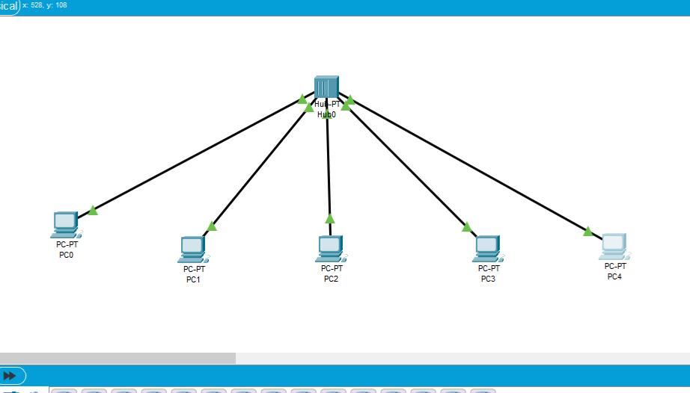**Each device check the IP address and if it is not for that device then devices ignore that massage.**
* **The receiver device receives the message and send the acknowledgement to sender.**
* **In this way the HUB works.**

**SWITCHES :-**

1. **A switch operates in the layer 2, i.e. data link layer of the OSI model.**
2. **It is an intelligent network device that can be conceived as a multiport network bridge.**
3. **It uses MAC addresses (addresses of medium access control sublayer) to send data packets to selected destination ports.**

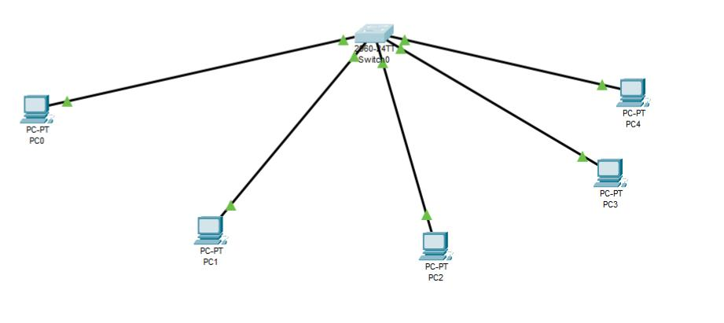

**4.In this diagram there are 5 device connected to the switch.**

**5.pc1 is the source which sends the message to pc2 which is destination .**

**6. As switch is intelligent device it sends message only to the pc2 unlike HUB. After message passing pc2 sends acknowledgement to pc1 as to represent the completion of task.**

**Router --**

1. **A router is a layer 3 or network layer device.**
2. **It connects different networks together and sends data packets from one network to another.**
3. **A router can be used both in LANs (Local Area Networks) and WANs (Wide Area Networks).**
4. 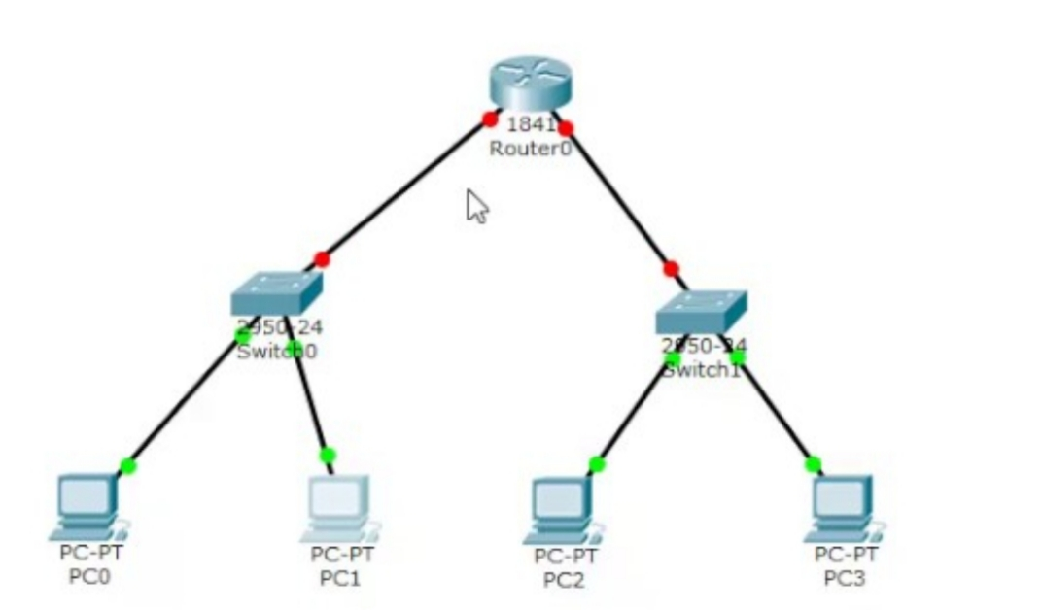**It transfers data in the form of IP packets. In order to transmit data, it uses IP address mentioned in the destination field of the IP packet.**

**5.In above diagram router is connected to two switches and switches are connected to 2 devices respectively.**

**6.Here source is pc0 and destination is pc3 .**

**7.Message passes from pc0 to switch then switch0 detects that were to send message and then sends to router .Router identify IP address and then send to switch1 .**

**8. Switch 1 detect the destination and then send message to pc3. Pc3 sends the acknowledgement to the source as completion of process.**